**Atlanta Daily World**

The Atlanta Daily World is the oldest black newspaper in Atlanta, Georgia. It was the Southern United States' most influential daily newspaper in the 20th century. Currently owned by Real Times Inc., it publishes daily online and weekly in print. It was founded as the weekly Atlanta World on August 5, 1928 by William Alexander Scott II who was only 26 at the time. Scott was a Morehouse graduate who later worked as the only black clerk on the Jacksonville to Washington, D.C. rail line, then in 1927 published a Jacksonville business directory to help blacks find each other. A year later he published a similar directory for Atlanta.

William Alexander Scott II, the founder of the Atlanta Daily World newspaper, was born in 1902 in Edwards, Mississippi. Scott, who was educated at Morehouse College around World War I, initially began publishing a business directory in Atlanta. However, he was interested in encouraging conversation and interaction among the black residents of Atlanta so, with the encouragement of black business owners in the city, he began to publish the Atlanta Daily World on August 5, 1928.  At the time Scott was 26. At the time, there was very little coverage of black educational institutions, businesses, prominent persons, churches, or other news of significance; the exceptions being crime news and death listings. This was despite the fact that Atlanta contained at the time the most prominent black educational institutions and persons of influence in the country. Whites lived to a large extent sealed off from black Atlanta and only interacted with blacks in service positions, virtually unaware of the black institutions and achievements taking place only a mile or two from their homes. The paper became a semi-weekly in May 1930, and a triweekly in April 1931. In 1931, Scott also began publishing the Chattanooga Tribune and Memphis World, and by doing so, founded the first chain of black newspapers, a chain that would eventually grow to a peak of fifty publications.

Although Scott credited much of his success with the Atlanta Daily World to his mother, Emmeline Scott, he also took advantage of the opportunity to publish a major black newspaper in rapidly growing Atlanta. Using subscription agents to go door to door, he developed a readership that eventually stretched beyond the Georgia capital.  He also promoted the paper as a business venture rather than as a tool for politicians and thus was able to attract advertising from both black and white businesses including national companies such as Sears and Coca-Cola as well as prominent local businesses.  In 1931 Scott developed the Chattanooga Tribune and the Memphis World, the first two of what would eventually become a chain of fifty newspapers.

William A. Scott did not live to see all of his plans for the newspaper business come to fruition. He was shot and killed outside of his own home in 1934. No one was ever convicted of his murder.

Younger brother Cornelius Adolphus Scott (1908-2000) took over the operation after his death.  C.A. Scott, as he was generally known, was educated at Morehouse and Morris Brown Colleges in Atlanta and the University of Kansas.  He continued to publish news of general interest to black Atlanta but he also steered the newspaper toward politics.  A prominent conservative Republican, the editorial pages now reflected his views.

The Daily World however did continue to cover police brutality cases, lynchings, and the Scottsboro cases throughout the 1930s, and supported efforts to promote black businesses. In the 1940s it campaigned against school segregation and the mistreatment of black soldiers in World War II.  The paper also supported voter registration campaigns.  In 1944, the Daily World became the first black newspaper to have an African American cover the White House.  
  
By the 1960s C.A. Scott opposed the sit-ins and other direct action protests that swept across Atlanta and the South. He argued that challenging school segregation, voter registration, and the growth of black wealth through business ownership would be more effective strategies for ending racial oppression.

C.A. Scott stepped down as publisher of the Atlanta Daily World in 1997 after sixty three years at the helm of the newspaper.  Alexis Scott, granddaughter of W.A. Scott, was named publisher. Three years later in May 2000, Cornelius Adolphus Scott died in Atlanta at the age of 92.   
  
Many prominent journalists began their careers at the Atlanta Daily World including: Lerone Bennett, Jr., Executive Editor Emeritus, Ebony Magazine, Paul Delaney, a former New York Times editor, and Yvonne Shinhoster Lamb, an editor at the Washington Post.

In 2008 the [Downtown Atlanta tornado](http://en.wikipedia.org/wiki/2008_Atlanta_tornado_outbreak) damaged the World's offices at 143 Auburn Avenue. The paper's operations subsequently moved to another location. In 2012 Scott announced plans to sell the building where this important part of Atlanta's black history took place; the buyer had plans to demolish the building. This caused outcry in the local [Old Fourth Ward](http://en.wikipedia.org/wiki/Old_Fourth_Ward) neighborhood at the loss of yet another historic building on Auburn Avenue. The [Historic District Development Corporation](http://www.hddc.net/), whose mission is historic preservation in the [Martin Luther King, Jr. Historic District](http://en.wikipedia.org/wiki/Martin_Luther_King,_Jr._National_Historic_Site) launched an [online petition](http://www.change.org/petitions/tell-integral-gsu-don-t-demolish-the-atlanta-daily-world-building) to save the building. Owner and publisher Alexis Scott responded in a joint statement with developer Integral Group claiming that demolition of the building but saving the façade was the only feasible option to preserve any portion of the historic structure and thus preserve the history in some physical form.

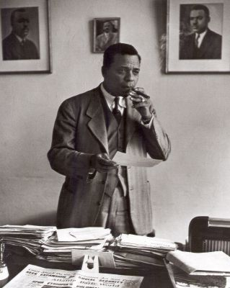

C.A. Scott, Editor of the Atlanta Daily World

Image Courtesy of Photos by Griff Davis

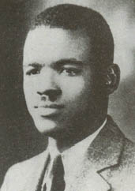

William Alexander Scott II